WORK LOG Field Geophysics software proposal

February 9, 2016

Using Matlab’s GUIDE to make a GUI that will read in time picks, plot them and generate an image of the subsurface structure with the ray paths.

Using as a sample data file picks from file 303.dat, which have been corrected for a time zero problem on the trigger, in directory

Dropbox/KruseUSF/AppliedGeophyscis2015/SandHill_FieldProject/SandHill_Data_Organized_By_Location/LineC/Seismics/LineC_Reflex/, using the procdata version of the file. Shot position = 65.5

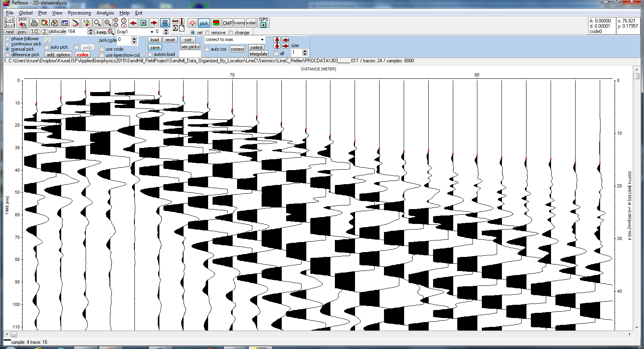

Write a little script to convert reflex picks to .mat. (Eventually Charly’s code will do this.)

Assigning all picks – programming now.

February 10, 2016

To do – how to work with two plots – not yet

Turn on windows sequentially - Done

Lessons learned the hard way: the function exist does not work inside a gui, neither does evalin for local variables

February 11, 2016

To do: make left slider selection for left-traveling refracted arrivals

Add toggle button to show best-fitting lines.

Getting overwhelmed by length of script 🡪 reviewed Matlab code folding

Note if you code fold all it nicely collapses all functions

February 16, 2016

When move slide, it doesn’t undo the line plot. Lines are plotted two places: one when the button is pushed, and two when the slider is moved. So when slider is first moved, delete the handle to the line.

Variable list to keep track of what’s on and what’s off

% not all of these are necessary here, but this serves as a list of the

% flags

handles.isShotSet = 0;

handles.doLinePlot = 0;

handles.RefractLeftPanelOn = 0; handles.RefractRightPanelOn = 0;

handles.isDirectLeft = 0; handles.isDirectRight = 0;

handles.isRefractLeft = 0; handles.isRefractRight = 0;

handles.isSlopeRefractLeft = 0; handles.isSlopeRefractRight = 0;

handles.isLineDirectLeft = 0; handles.isLineDirectRight = 0;

handles.isLineRefractLeft = 0; handles.isLineRefractRight = 0;

Lessons learned:

handles returns a nonzero value when feature is plotted, not necessarily the value 1.

Make sure that anytime a line is created or deleted, the “is” variable is also changed

Now get file 307 to have a shot with significant picks to left. Shot location 81.5

To do next: add ray diagram